

Sri Lanka Institute of Information Technology

Project Proposal

**Information Technology Project (IT2080)**

**2021**

**Online Pharmaceutical Ordering System for Healthymart Pharmacy**

**Group ID:**

ITP2021_S2_B05_G02

**Details of the Group Members:**

|  |  |  |  |  |
| --- | --- | --- | --- | --- |
|  | **Name with Initials** | **Registration Number** | **Contact Phone Number** | **Email** |
|  | Rathnayake R.K.A.R | IT20189594 | 070 292 6667 | it20189594@my.sliit.lk |
|  | Mallawarachchi S.M.A. | IT20200206 | 071 612 2318 | it20200206@my.sliit.lk |
|  | Dilshan A.J.Y.J | IT20148454 | 071 309 0664 | it20148454@my.sliit.lk |
|  | Wijesiriwardana H.G.N.D | IT20191788 | 071 247 0076 | it20191788@my.sliit.lk |
|  | Silva K.V | IT20126292 | 076 446 5200 | it20126292@my.sliit.lk |
|  | Manaram.M.G.T | IT20124076 | 071 174 2203 | it20124076@my.sliit.lk |
|  | Jayawardana J.K.M.D.T | IT20129576 | 071 209 3732 | it20129576@my.sliit.lk |
|  | Asahara G.A | IT20187132 | 076 251 6563 | it20187132@my.sliit.lk |

**CONTENT**

1. **Introduction---------------------------------------------------------------------------------**

**03**

03

03

03

**04**

**04**

**05**

05

06

07

08

09

10

11

12

**13**

**15**

**16**

**17**

**19**

Company or client/ background-----------------------------------------------------------

Problem statement and difficulties they face--------------------------------------------

Solution to the above problem-------------------------------------------------------------

Benefits of the proposed solution----------------------------------------------------------

1. **System Overview---------------------------------------------------------------------------**
2. **System Functions---------------------------------------------------------------------------**
3. Customer handling------------------------------------------------------------------
4. Admin access------------------------------------------------------------------------
5. Drug stock handling----------------------------------------------------------------
6. Purchase an item--------------------------------------------------------------------
7. Drug item reservation--------------------------------------------------------------
8. Access purchase history------------------------------------------------------------
9. Item delivering----------------------------------------------------------------------
10. Manage Customer Inquiries and Feedbacks-------------------------------------
11. **Tools and Technologies ------------------------------------------------------------------**
12. **Constraints/Limitations------------------------------------------------------------------**
13. **Gantt Chart---------------------------------------------------------------------------------**
14. **Work distribution among members (Tabular format)-----------------------------**
15. **References------------------------------------------------------------------------------------**

**INTRODUCTION**

**Company or client/ background**

* Healthymart Pharmacy has 6 branches spread a across the country. All six of these branches are managed under specific manager and employed by 6-7 employees. These 6 branches are located in Colombo, Gampaha, Kandy, Matara, Galle, Jaffna.

**Problem statement and difficulties they face**

* Because of the rapid growth of Covid 19 patients in the country, consumerism of medicine in local pharmacies have increased. Because of that it is hard to maintain the social distance among customers. Therefore, there’s a huge risk of increasing the chances of virus spreading.
* As for the safety reasons the owner of the pharmacy has decided to limit the employees in each branch therefore the company’s service efficiency has reduced. This is negatively affecting company’s economy.
* As the pharmacy branch network is quite large, there is difficulty in management due to this pandemic situation.

**Solution to the above problem**

* Due to these reasons, we are planning to handle pharmacy procedure through a web base application. Therefore, this system will be created concerning the safety of citizens due to the prevailing Covid 19 pandemic in the country, further maintaining and controlling social distance in order to prevent the growth of the virus.

**INTRODUCTION**

**Benefits of the proposed solution**

* This system will help to ease up the business management and will improve sales that have been dropped.
* Company owner can easily manage every branch through the system, thus reducing the time waste.
* Overall pharmacy activities will be efficient.
* Because this is an online system, whole managing processes can be done by a limited number of employees. Therefore, additional costs will be reduced.
* Customers can safely order their drug items and can be

delivered to their doorstep easily.

**SYSTEM OVERVIEW**

**SYSTEM FUNCTIONS**

1. **Customer Handling: -**

* All customers should register to the system. After login to the system, the system will access the customer details including customer’s name, customer’s id, current location and display on customer’s profile.
* **An overview of customer handling function**

Customer Handling is the main function on this area. The main database that will be created for this function is Customer_DB. Only the admin and Customer Manager access to this function. Main admin and customer manager only can do CRUD operation on this database named as Customer_DB.

Admin and Customer manager can: -

* + Add New customer who unable to register on normal way.
  + Edit Customers details once the customer can’t update his details.
  + Delete customers who are not interact with the system and once their customer request to delete his account from the system.
* Search the customers and generate a report on using customer details.

Finally In this function We have to generate customer report in there we can generate report using customer details in the Customer_DB. In the report we have to plan to add the customer’s name and other details to it.

Whenever once the customer login There is another function to Identify customer location because we need to detect his location to deliver the medical things to buyer.

1. **Admin access: -**

* Each subbranch has an admin (sub-admin), all subbranches are handle by their head admin (System owner),
* When head of admin login to the system he/she can add or remove other sub admins and each sub admins can update their activity details (login details, profile details, etc...). Head of admin can generate an admin log report for get information about the login activities and remove sub administrators from the system.
* **An overview of admin access function**

Admin access is one of a main function according to this system. It’s handled main administrative functionalities. There are 4 functions,

* **A**. Add new administrators to the system (By using AdminDB).
* **B**. Update and removing admin details from the system (By using AdminDB).
* **C**. Generate log report for attendance monitoring purpose.
* **D**. Search and edit sub administrator’s profile details.

**A**, **B** & **C** functions are handling by the system admin but in this stage, sub admins can only access for the function **D.**

And finally, to do these processes,

System has two kind of a main actors and involve to manage above mentioned functions.

* Main Actors:
* System administrator (Pharmacy owner)
* Sub-admins (Branch Managers)

**AdminDB:** Database that are we used to manage this whole process. (Create/Update/Delete/Retrieve/Report generation/Search)

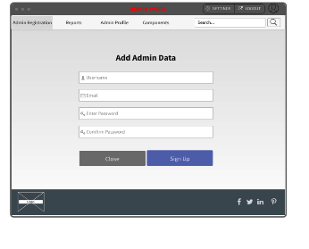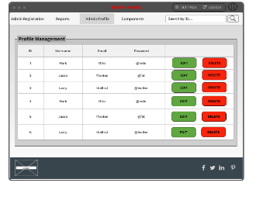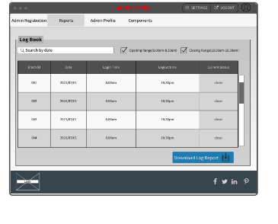

**Update & remove admin details**

**Generate admin log report**

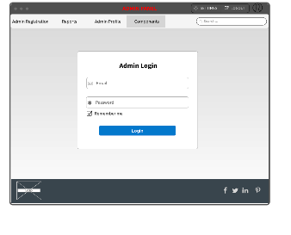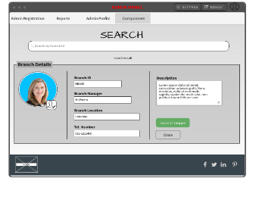

**Admin login**

**Add admins**

**Search sub-admins**

**System Owner (Head Admin)**

1. **Drug stock handling: -**

* Drug stock handle by the admin, an admin can add or remove items (Drugs/Medicine) from the system and generate a summary report (newly added stock, details of sold items, remaining stock).
* **An overview of drug stock handling function**

Drug stock handling is the one of main function of this system. The main database that will be created for this function is **DrugStock_DB**. Only the Admin can manage this function in the system. Admin can do all crud operation in the **DrugStock_DB**.

He can,

* add new products
* edit products (Update)
* delete product
* view and search

from Drug stock handling function. As well as he can generate an report through this function. There are 2 important report that admin can generate. These are “Sales summary” and “Remaining products”.

Remaining products report

With the help of **purchase_Item_DB** and **DrugStock_DB**, report function can calculate the difference between these two databases, finally admin can calculate the remaining items of the system. This report will be helpful to admin to get an idea how many products he should purchase for the next month.

Sales summary

And the next report is Sales report. In the sales report there is every purchase details item wisely. After getting the purchase details, Admin can calculate the difference between all product cost and all sales, finally he can calculate the overall profit in the month. These things can be done by the Admin from Drug Stock Handling function.

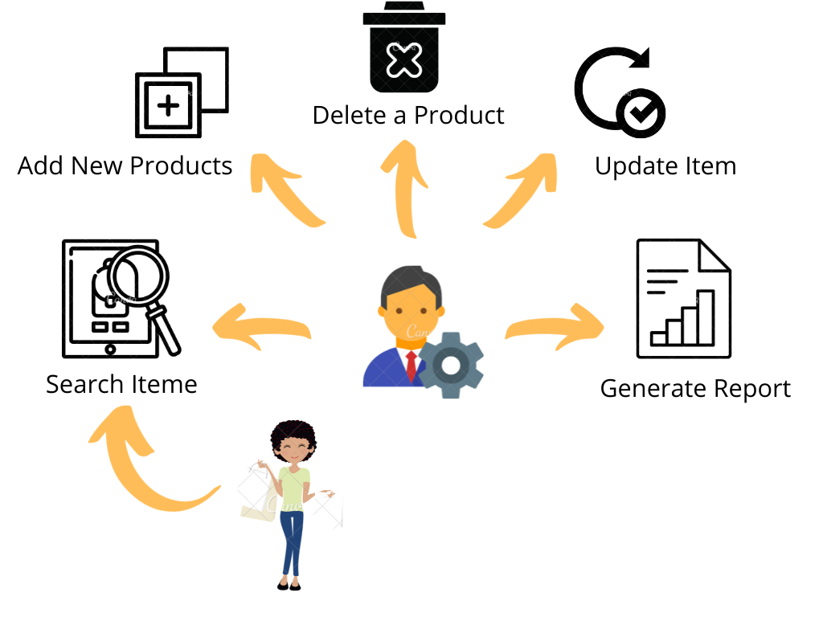

**Admin**

**Customer**

1. **Purchase an item: -**

* Customer can add item to the cart or search items from the system then he/she can update quantity for each item, if customer wants to remove an item, he/she can do it from item cart or cancel the order. Finally, system will automatically generate an invoice for the transaction.
* **An overview of purchase an item function**

Purchase an item function is a most important function of this system. “Shopping Cart” is the main part in this function. Mainly this function uses Stock Database and Sales Database. Customer is the main actor in this function. They can,

* Search items from the store
* Add items to the cart
* View added items in the shopping cart
* Update items quantity in the cart
* Remove items from the cart
* Clear Cart

In the Cart page, if customer want to add more items, then he/she can do it by clicking “Continue Shopping” button. It will redirect to the store. After customer click the “Proceed to Checkout” button System generate an invoice report and it is saved in Sales DB. As well as it can be view and download by the customer. Then he/she can view his/her purchased items and total of the order.

1. **Drug item reservation: -**

* If the customer has the prescription, then customer can upload the prescription to the system. If customer want to remove or change the uploaded prescription, then customer should do that before the given time period. A report will be generated depending on the situation (pending, successful, rejected).
* **An overview of purchase an item function**

If customers want to get drugs which is prescribe by their doctor, then those customers

can simply upload a photo of their prescription to the web application. Here customer is

allowed to access following options:

* Upload prescription
* Delete uploaded prescription
* Add/reupload another prescription (extra images)
* View uploaded prescription

Incase if customer wants to upload more than one image of prescription or if customer wants to remove the uploaded prescription, then customer is allowed to do so but withing a limited time period (default timer is 30 minutes). After the time period system will save the customers uploaded prescription to **Prescription_DB**.

Administrator can handle customers uploaded prescription. Administer has following options:

* View prescription
* Search uploaded prescriptions (using customer id)
* Generate a report

Administer can view uploaded prescription by accessing **Prescription_DB.** Administer can mark those prescription as completed or invalid according to their choice (Customer will be notified by an email in both cases). All completed prescription will be stored in **completedPres_DB**. Invalid prescriptions will be stored in **invalidPres_DB.** Admin can see prescription information details (new, valid, invalid) in admin UI. Admin can generate a detailed report about prescription summery(weekly/monthly).

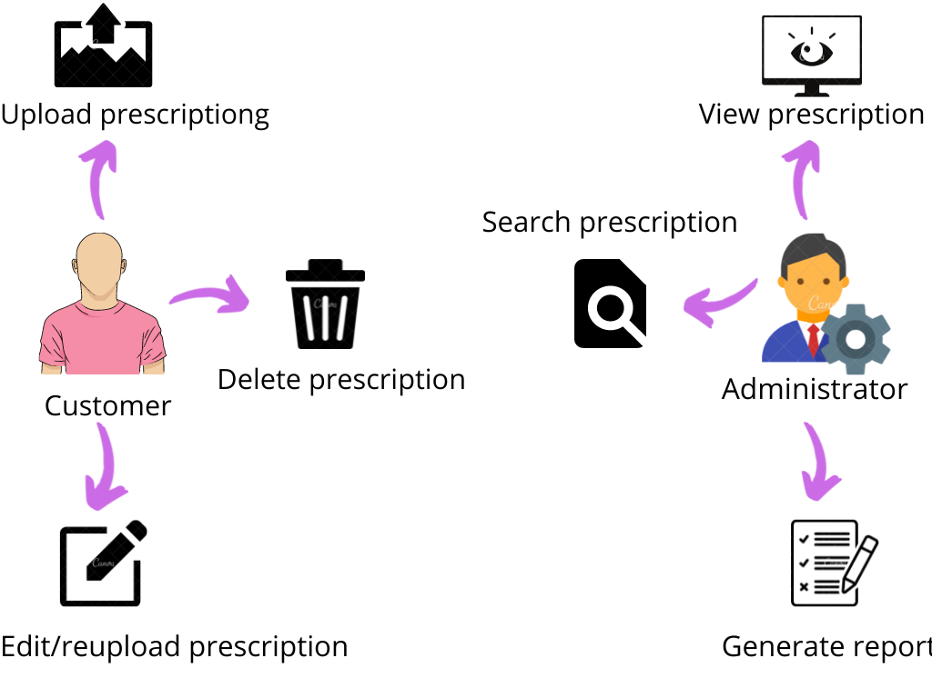

1. **Access purchase history: -**

* System will generate and display customer’s previous transactions. Customers can re-order or add item to the favorite list (this option is only available for customers without prescription) from the purchase history section.
* **An overview of access purchase history function**

Access Purchase History function is one of the important part in this system. In shortly, this System will generate and display customer’s previous transactions. Customers can re-order or add item to the favorite list (this option is only available for customers without prescription) from the purchase history section. And also, this “**Access purchase History**” function divided to five sub functions.

* View transaction history
* Re-order items
* Delete transaction history
* Add Transaction/Items for favorite
* Search specific customer history

According to above sub functions, some functions are related with the users (Customers) and some functions are related with the administrators.

By using **view transaction history** function, user can view their pervious transaction details (Customer ID, Name, item ID, price, transaction date) such as details are displaying in a table.

**Re-order items function** also related to the user because of that, customers can re-order his/her previous items through the transaction history table (historyDB). It will be helpful to customers for order their items.

Through the **delete transaction history** function, customers can handle (remove transactions from the history) their transaction details then system will automatically delete that customer’s record from the database (transactionDB).

And **add transaction function**, user can add some items to their favorite item list. Then it will add to another table called favorite item table (favoriteDB).

Finally **search specific customer history** function related to the admin. Admin can search specific customer’s transaction details then after getting those details, if admin wants to generate detail report then he/she can generate report and get it. This function specially for inquiry cases of the customers.

1. **Item delivering: -**

* System retrieves customers default location details to deliver the order. Customer is also able to add an optional delivery address to the system. System will generate a finalized customer location report (used by delivery person). Progress bar is applied to indicate the progress of the customer’s order process (starts from purchase section and ends with delivery section).
* **An overview of item delivery function**

Item delivering function is very important in this system. In here shows the process between administrator, delivery person and customer.

In here they can,

* Get location information.
* Add optional delivery details.
* Search customer orders.
* Generate delivery report.
* View progress bar.

Get location information, search customer orders and generate delivery report are handled by the administrator. System retrieves customers default location details using **"Customer DB"** to deliver the order. Customer is also able to add an optional delivery address to the system. Then Administrator can view the customer’s optional delivery details using **"Optional Delivery Info DB"**. In here administrator can get the customer's details searching customers ID's. After System will generate a finalized customer location report. It used by delivery person. Finally, the system generates a progress bar. It is applied to indicate the progress of the customer’s order process (starts from purchase section and ends with delivery section).The customer and the administrator also can view the progress bar.

1. **Manage Customer Inquiries and Feedbacks: -**

* After customer completed the order, customer can leave a feedback then all customer feedbacks will be collected a displayed on about-us section in the system.
* **An overview of manage customer inquiries and feedback function**

This is one of the main functions in this system. This system has **Feedback_DB** and **Inquiry_DB**. Only the admin can access these two types of databases. If customers put feedback or inquire admin can quickly respond to that. In this system, there are seven types of sub-functions.

**Customer:**

Customer has four sub-functions in this system. There are,

* Add feedback
* Delete feedback
* Edit feedback
* Add inquires

Using these sub-functions customer can add, delete or edit feedback according to his satisfaction. As well as after customer completed the order customer have any issue about an item or other services customer can add a inquire and send it to the admin.

**Admin:**

Also, admin has three sub-functions in this system. There are,

* View all customer feedback
* View all customer inquires
* Filter customer feedbacks and generate a report

Using these sub-functions admin can view all feedbacks and "**Generate summary report**" about customer feedbacks using **Feedback_DB**. As well as admin can view all customer inquiries and solve those inquiries. If the admin wants to filter all positive and negative feedbacks, he can filter feedbacks using the filter option.

**TOOL & TECHNOLOGIES**

* **Logo

  Description automatically generatedTools:**
* **Vs code**

Visual Studio Code is a lightweight but powerful source code editor which runs on your desktop and is available for Windows, macOS and Linux. we use vs code to design our frontend developments.

* **Postman**

**Postman** is the only complete API development environment. The comprehensive set of built-in tools support every stage of the API lifecycle so individuals and teams can easily maintain a single source of truth. You can design and mock, debug, test, document, monitor, and publish your APIs from the Postman UI. Postman allows you to manage your APIs on the Postman native apps for MacOS, Windows, and Linux, with Newman, Postman's command line tool, and via the cloud using Postman Monitoring.

* **Technologies:**
* **Icon

  Description automatically generatedNode Js**

Node.js is an open-source and cross-platform JavaScript runtime environment. It is a popular tool for almost any kind of project!

* **A picture containing text, device, gauge

  Description automatically generatedMongoDB**

 MongoDB is a document database designed for ease of development and scaling. The Manual introduces key concepts in MongoDB, presents the query language, and provides operational and administrative considerations and procedures as well as a comprehensive reference section.

* **Icon

  Description automatically generatedReact**

React makes it painless to create interactive UIs. Design simple views for each state in your application and React will efficiently update and render just the right components when your data changes.

Declarative views make your code more predictable and easier to debug.

* **Icon

  Description automatically generatedExpress**

Express is a minimal and flexible Node.js web application framework that provides a robust set of features for web and mobile applications.

* Logo, icon

  Description automatically generated**Bootstrap**

Bootstrap is framework to manage websites speedier. It consolidates HTML and CSS based arrange formats for typography, shapes, buttons, tables, course, modals, picture carousels, etc. It as well gives you support for JavaScript plugins.

**CONSTRAINCE / LIMITATION**

* Client recommended us to develop his web application by using JavaScript language.
* The overall system should be developed within the given budget.
* The system should be delivered within 8-12 weeks.
* The system has a short responding time for every function.
* System provides a competitive environment.
* The system should provide access controlling for both parties (Administrator level & User level).
* The system database should be designed to the needs of application it is supporting.
* The system provides user friendly interfaces.
* The system should be able to provide a better security to secure customer’s privacy.

Feasibility Study

Requirements Gathering & Analysis

Develop a solution (Design Phrase)

Code the solution

(Implementation Phrase)

Testing and Debugging

Launch the system

Gantt Chart

Weeks

01 02 03 04 05 06 07 08 09 10 11 12

**System Development Life Cycle**

**GANT CHART**

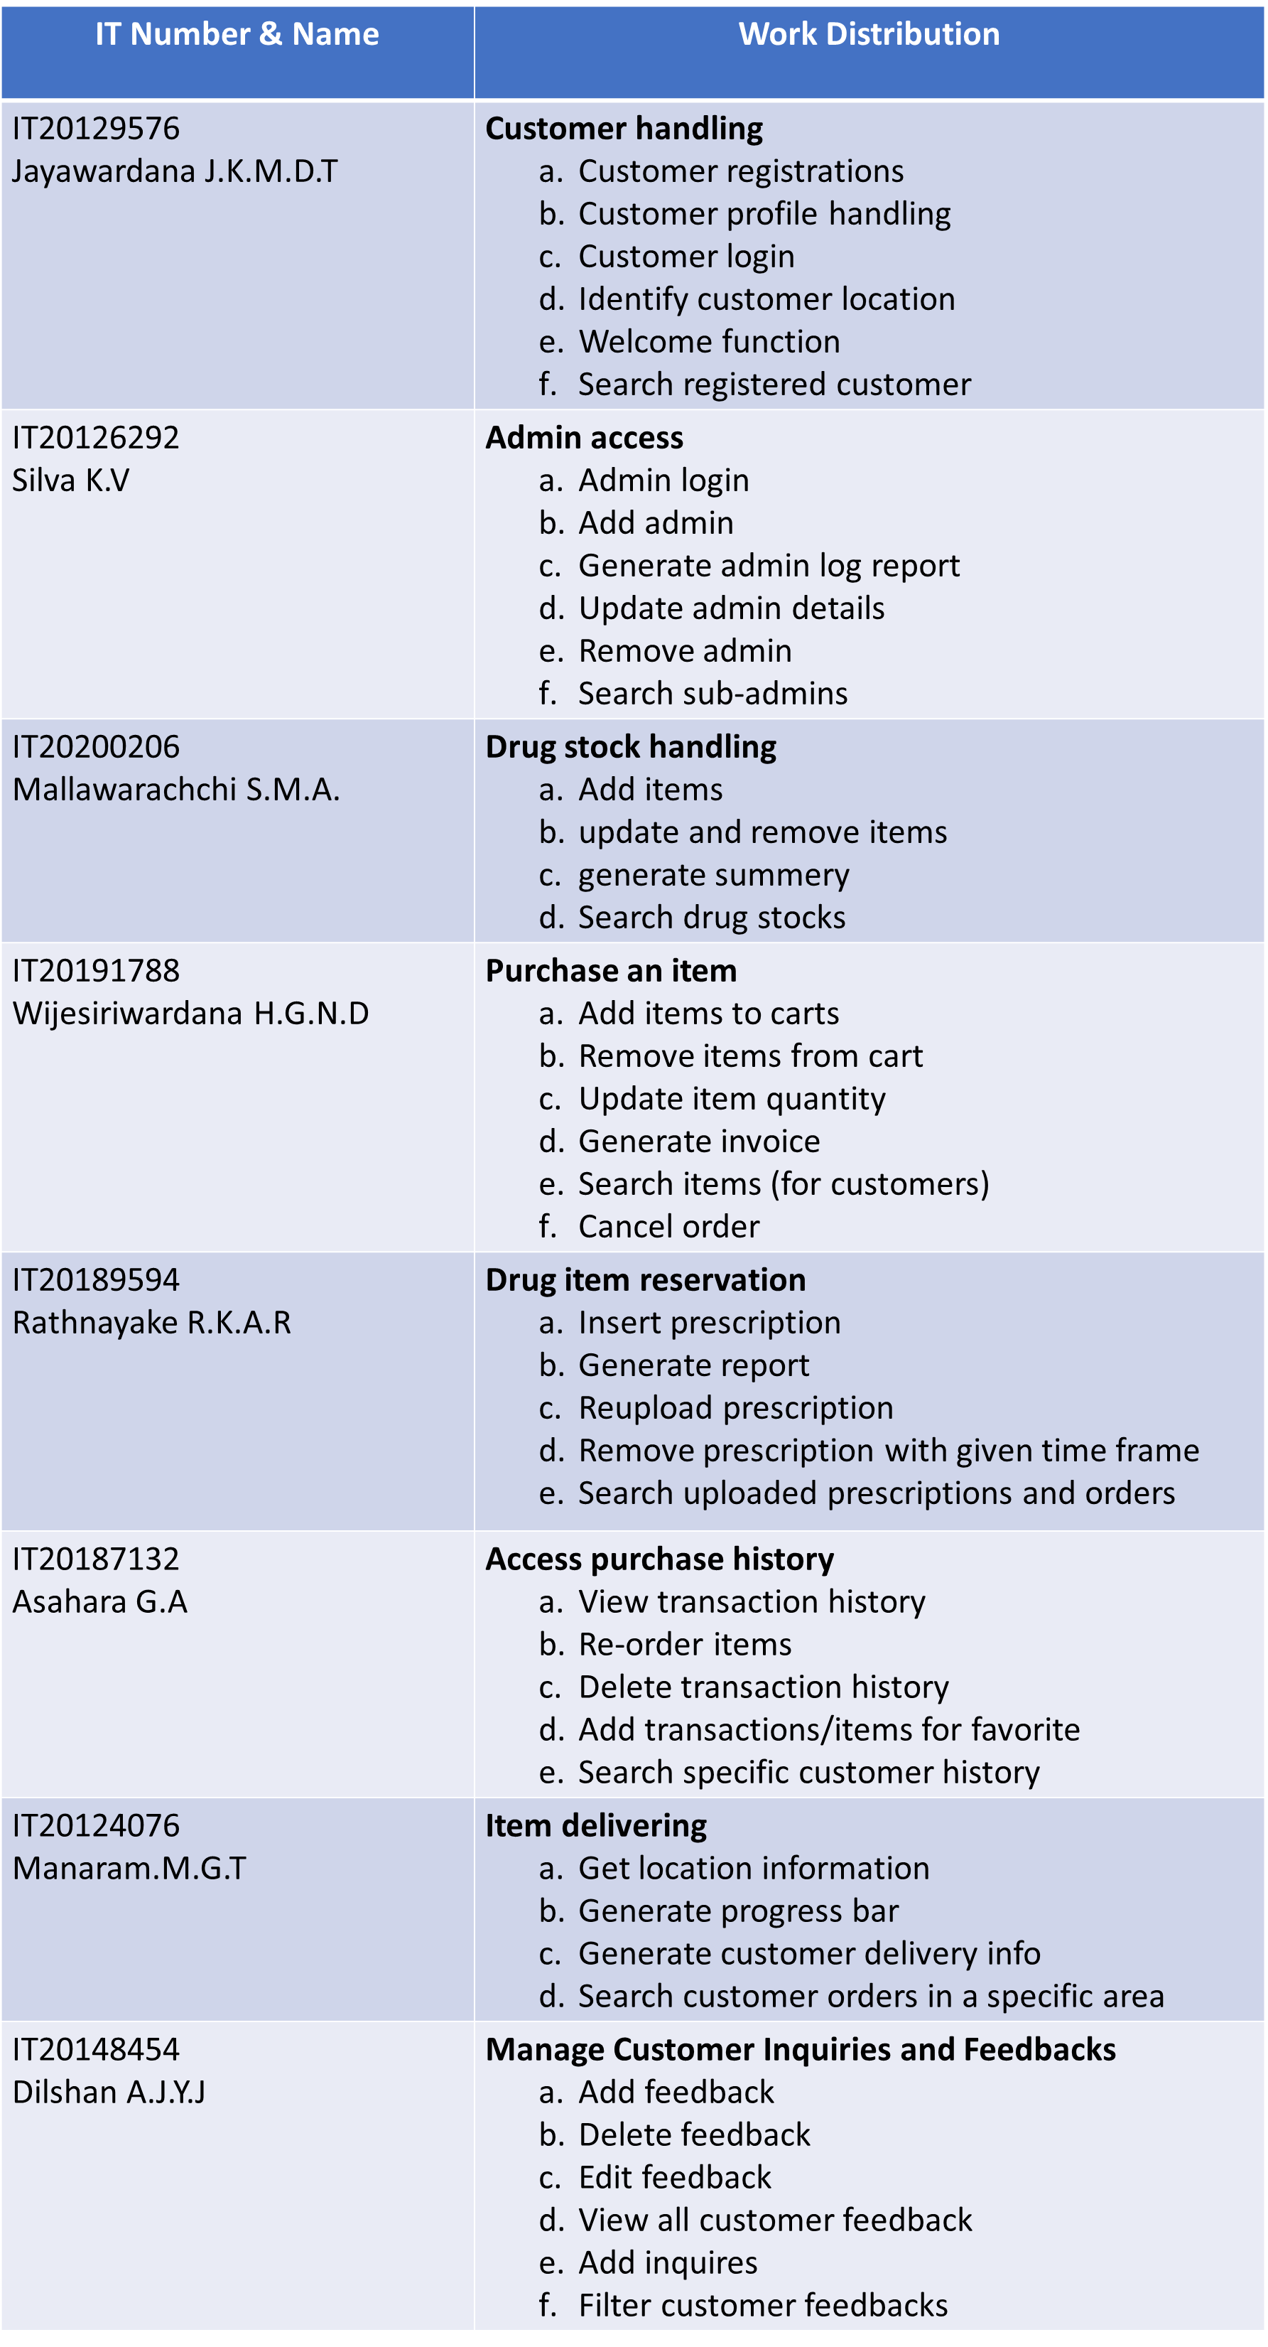

**WORK DISTRIBUTION AMONG TEAM MEMBERS**

**WORK DISTRIBUTION AMONG TEAM MEMBERS**



* **Vs Code**

**REFERENCES**

[**https://code.visualstudio.com/**](https://code.visualstudio.com/)

* **Postman**

[**https://www.postman.com/**](https://www.postman.com/)

* **Node Js**

[**https://nodejs.org/en/**](https://nodejs.org/en/)

* **MongoDB**

[**https://www.mongodb.com/**](https://www.mongodb.com/)

* **React**

[**https://reactjs.org/**](https://reactjs.org/)

* **Express**

[**http://expressjs.com/**](http://expressjs.com/)

* **Bootstrap**

[**https://getbootstrap.com/**](https://getbootstrap.com/)